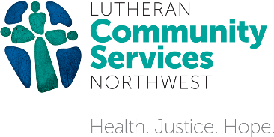
REFUGEE STARTER KITS
Most refugees arrive in the United States with next to nothing, but you can help them rebuild their lives by putting together a restart kit. Choose a category below, place the items in a box or plastic tub that can close, and label the top of the container with the kit name (do not tape closed). We want to honor the refugees coming here, so please purchase new items. You’re also welcome to include a handwritten, unsealed welcome note with your kit.
For information and kit donation pickup or delivery please email SIV@lcsnw.org

Personal Care Kit

Toothbrushes (4-6)
Toothpaste (2)
Shampoo (2)
Conditioner (2)
Deodorant (4)
Bars of Soap (3)
Razors (2)
Shaving Cream (2)
Feminine Hygiene Pads
Toilet Paper (6)
Notebook and Pens
Calendar (optional)

Baby Kit
Choose an age or size and include on kit label

Diapers
Baby Wipes
Any small baby items you’d like to include (onesies, rattle, pacifier, etc.)
Cleaning Kit

Mop and Bucket
Broom and Dustpan
Pack of Sponges
Bottle of All-Purpose Cleaning Spray
Toilet Brush
Dish Soap
Laundry Detergent
Light Bulbs
Paper Towels (2)
Tissues (2)
Bathroom Kit

Bath Towels and Hand Towels (4 of each)
Washcloths (6-8)
Shower Curtain with Rings
Hand Soap
Toilet Paper (6)
Small Waste Basket
Kitchen Kit 2

Mixing Bowls (2-3)
Plastic Storage Containers
Frying Pan
Small Pot with Lid
Large Pot with Lid
Baking Dishes (Glass or Ceramic)
Cutting Board
Large Carving Knife
Smaller Paring Knife
Spatula
Can Opener
Teapot and Tea (optional)

Kitchen Kit 1

Dishes (Plates and Bowls for 6)
Cups/Glasses and Mugs (6)
Silverware (6-8)
Silverware Tray for Drawer
Dish Towels (2)
Potholders (2)
Paper Towels and Holder
Trash Can
Trash Bag

